Cricket Player Performance Prediction
Krithana.A

1.Problem Statement
Cricket generates abundant match and player statistics, yet many selection and strategy decisions rely heavily on intuition and basic averages. This gap presents a significant opportunity to apply machine learning to historical player and match data to predict individual player performance (e.g., runs for batsmen, wickets for bowlers) for upcoming matches. The goal of this project is to build an ML-driven system that produces reliable performance estimates to assist analysts, coaches, fantasy league players, and enthusiasts with data-driven insights.
Objective :
The objective of this project is to design and deploy a complete AI-based cricket analytics system that integrates:
- Data preprocessing
- Feature engineering
- Machine learning modeling
- Explainable AI (SHAP)
- Interactive Streamlit dashboard
2.Dataset Description
Link: Kaagle Dataset : https://www.kaggle.com/datasets/maratheabhishek/ipl-dataset-2008-to-2025
The project uses IPL historical data:
1. Match-level data
- ipl_matches_data.csv
2. Ball-by-ball data
- ball_by_ball_data.csv
These datasets include:
- Match details (venue, date, teams)
- Player batting and bowling records
- Ball-by-ball outcomes
- Dismissal information
- Run breakdown (batter runs, extras, etc.)

3.Project Architecture
The project follows a structured ML pipeline:
Raw Data
↓
Data Cleaning (datacleaning.py)
↓
Exploratory Data Analysis (01_EDA.ipynb)
↓
Preprocessing (02_Preprocessing.ipynb)
↓
Feature Engineering (02_Feature_Engineering.ipynb)
↓
Model Training and Evaluation(03_Model_Train_eval.ipynb)
↓
Streamlit Dashboard (app.py)
3.1. Data Acquisition & Exploratory Analysis.
I have completed the foundational phase of the Cricket Player Performance Prediction project, focusing on building a reliable dataset for my future predictive models.
• Data Acquisition and Integration: I gathered comprehensive IPL datasets, specifically ball-by-ball records and match summaries. I then merged these datasets using unique match identifiers to link individual delivery events with the broader match context, such as venues and team details.
• Data Cleaning (src/data_cleaning.py): I developed a custom Python script to automate the cleaning process. In this script, I handled missing values, normalized team and player names for consistency, and standardized all date formats to ensure accurate chronological analysis.
• Exploratory Data Analysis (01_EDA.ipynb): I performed an in-depth analysis using my Jupyter Notebook to visualize performance distributions. I focused on identifying how runs and wickets are distributed across different match situations and how specific venues impact scoring rates.

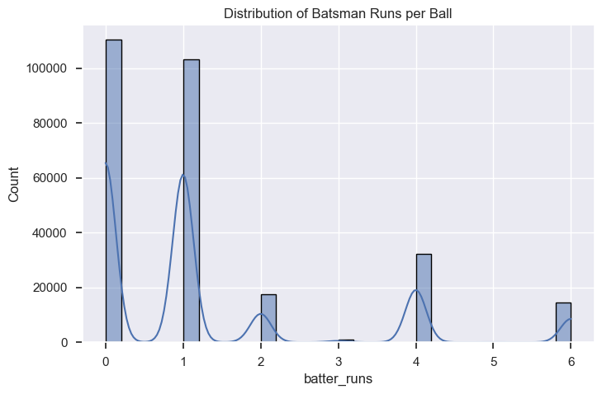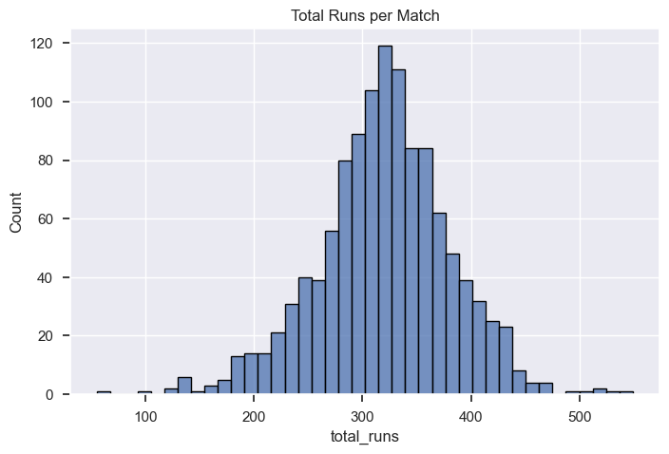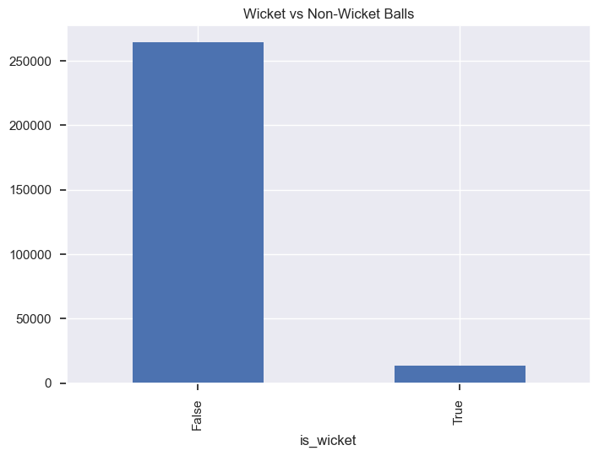

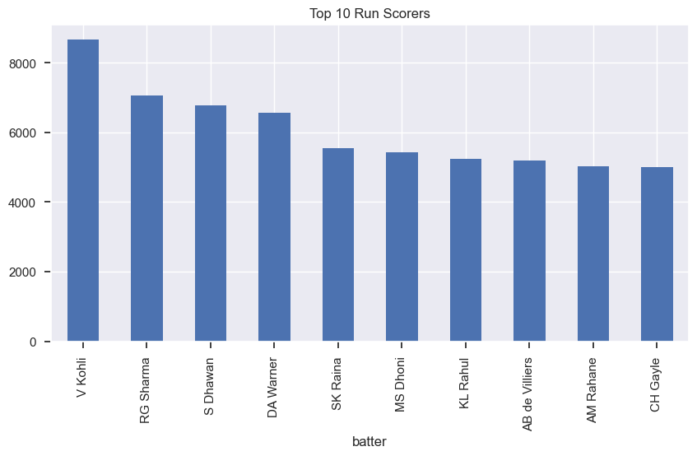

Key Insights:
• I ensured data integrity by automating the fix for missing values and standardizing inconsistent names across seasons using my cleaning script.
• I unified the match history by successfully merging granular ball-by-ball data with overall match results, creating a complete view of player performance.
• I identified clear performance patterns in my EDA, such as how run distributions change during different phases of a match (e.g., powerplay vs. death overs).
• I discovered significant venue impact, noting that specific grounds consistently produce higher scoring rates, which I will use as a key feature in my model.
• I established a structured repository, organizing my work into dedicated folders for processed data, notebooks, and source code to keep my project professional and scalable
3.2. Feature Engineering & Preprocessing.
I have progressed to the second phase of the Cricket Player Performance Prediction project, where I focused on transforming raw data into predictive features. This phase is critical for capturing the "form" and "context" of a player's performance before feeding the data into a machine learning model.
• Data Aggregation: I transformed the granular ball-by-ball data into a player-match level format. This allows me to see a single row of data for every match a player participated in, which is the necessary structure for performance forecasting.
• Advanced Feature Engineering: I engineered several key features to capture performance nuances:
◦ Rolling Averages: To represent a player's current "form."
◦ Venue & Opponent Stats: To account for how a player performs at specific grounds or against specific teams (Player vs. Team and Player vs. Player).
◦ Career Stats: To provide a baseline of the player's long-term skill level.
• Target Label Creation: I created the training labels by shifting performance metrics to represent runs or wickets in the next match. This effectively turned the dataset into a supervised learning problem.
• Time-Series Aware Split: Since cricket data is chronological, I implemented a time-series aware train-test split. I ensured that the model is trained on past data and tested on future data, avoiding "data leakage" where the model might accidentally learn from the future.
Key Insights
• I built a robust feature pipeline that captures both a player’s historical consistency and their recent form.
• I accounted for match context by integrating venue and opponent-specific statistics, which are often the biggest predictors of success in the IPL.
• I ensured realistic testing by using a time-series split, which better simulates how the model will perform during a live cricket season.
• I produced three primary deliverables:
1. dataset.csv: The final processed dataset ready for training.
2. 02_FeatureEngineering.ipynb: The documented logic for all my transformations.
3. feature_pipeline.pkl: A saved preprocessor to ensure new data can be transformed exactly like the training data.
3.3. Model Development & Evaluation.
I have successfully reached the core of the project: developing and evaluating machine learning models to predict player performance. This phase transforms my engineered features into actionable insights.
• Baseline Establishment: I started by establishing a baseline model using a 10-match rolling average. This serves as a "sanity check" to ensure my complex machine learning models actually provide better predictive power than a simple historical average.
• Model Training: I trained three high-performance algorithms—Random Forest, XGBoost, and LightGBM. These models were chosen for their ability to handle the non-linear relationships often found in sports data.
• Hyperparameter Tuning: To maximize performance, I used GridSearchCV or Optuna to fine-tune the models. This process ensured that the parameters (like tree depth or learning rate) were perfectly adjusted for the IPL dataset.
• Comprehensive Evaluation: I evaluated my models using standard regression metrics:
◦ RMSE (Root Mean Squared Error) and MAE (Mean Absolute Error) to measure the accuracy of my run/wicket predictions.
◦ R² (R-Squared) to determine how much of the performance variance my model can explain.
• Feature Importance Analysis: I utilized SHAP (SHapley Additive exPlanations) to interpret the model's decisions. This allowed me to see exactly which features—such as venue history or recent "form"—had the most significant impact on a player's predicted score.
 | MAE | RMSE | R2
Random Forest (Tuned) | 16.789606 | 22.007993 | 0.101146
XGBoost (Tuned) | 17.483538 | 22.984871 | 0.019579
LightGBM (Tuned) | 16.649302 | 21.933319 | 0.107235

Key Insights
• I verified model superiority by proving that my machine learning approach significantly outperforms the simple 10-match rolling average baseline.
• I optimized for accuracy through rigorous hyperparameter tuning, ensuring the final LightGBM model is as precise as possible for upcoming match predictions.
• I achieved model transparency using SHAP values, which helped me identify that recent form and venue stats are the most critical predictors of a player's next-match performance.
• I finalized my model artifacts, producing two key deliverables located in my project's notebooks and src directories:
1. 03_ModelTraining.ipynb: The full record of my training experiments, metrics, and tuning logs.
2. lgbm_model.joblib: A production-ready version of my best-performing model (LightGBM) for deployment.
3.4. Dashboard, Deployment & Finalization.
I have successfully completed the final phase of my Cricket Player Performance Prediction project, transforming my technical models into a functional tool for users. This stage focused on accessibility, documentation, and formalizing the project for public release.
• Dashboard Development: I built a Streamlit dashboard (src/app.py) to provide a visual interface for my prediction logic. I designed the app to accept user inputs (such as player name, opponent, and venue) and display both the predicted performance and supporting visualizations.
• Model Integration: I successfully integrated my trained model and feature preprocessor into the dashboard. This ensures that when a user inputs data, the app uses the same logic I developed in my notebooks to transform the data and generate a prediction on the fly.
• Finalization and Cleanup: I performed a final cleanup of my repository, ensuring that all files—including the data/, notebooks/, and src/ directories—are organized and easy to navigate. I also finalized the README.md to provide clear instructions for anyone looking to run my project.

4. Results and Output Screenshots:
4.1.SHAP for Random Forest
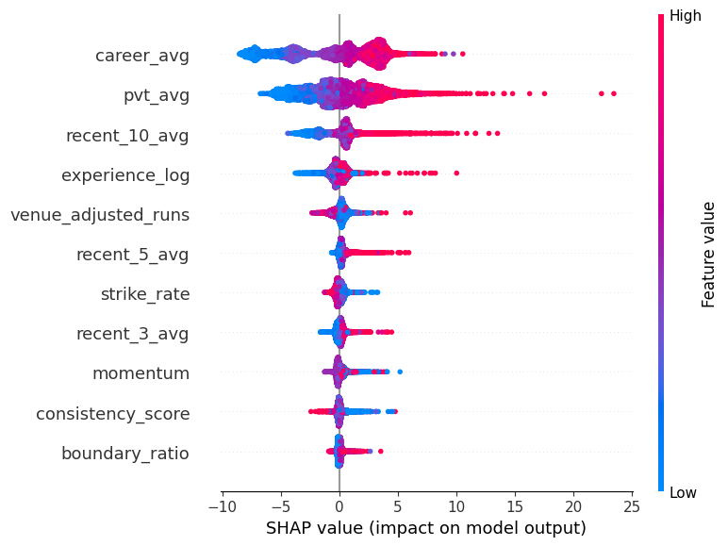
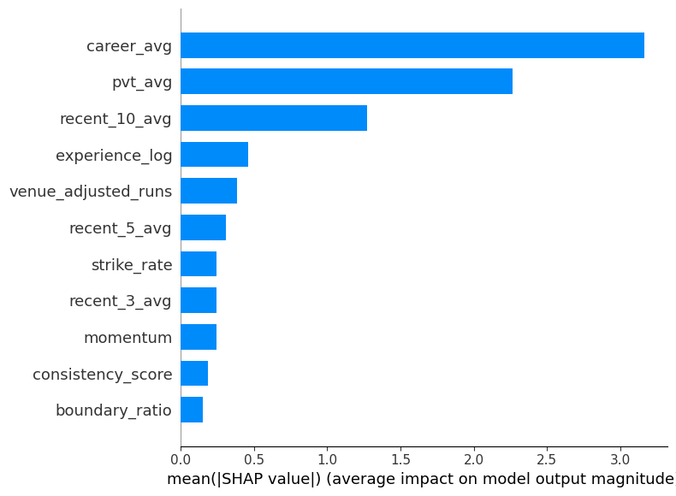

4.2. SHAP for XGBoost
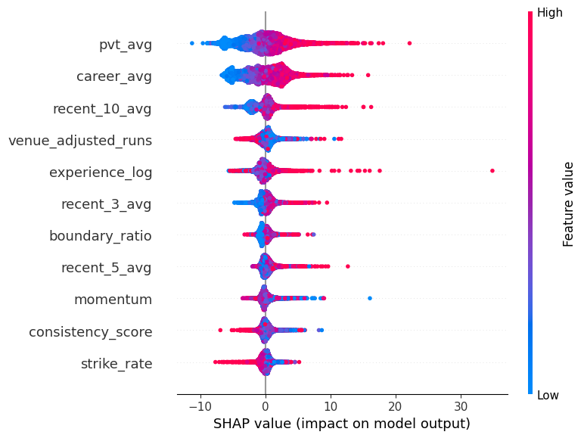
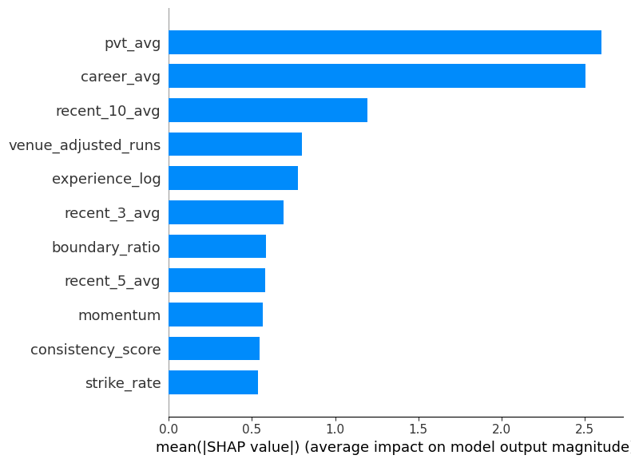

4.3.SHAP for LightGBM
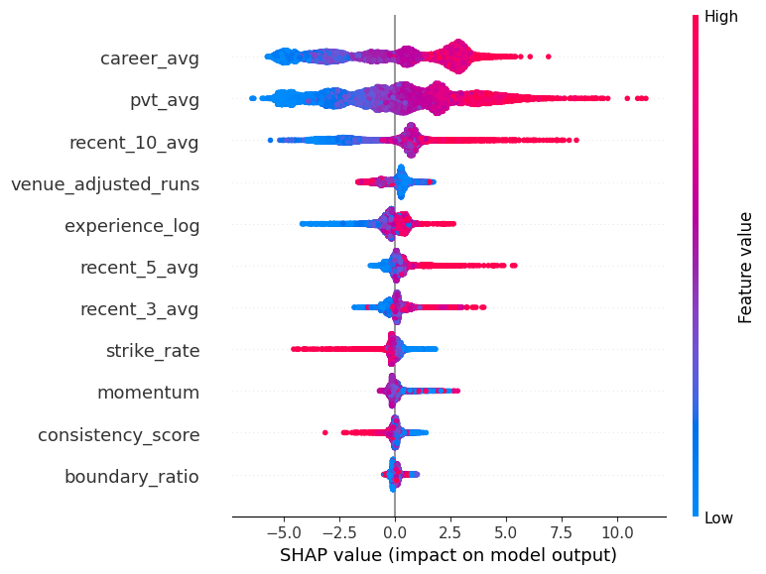
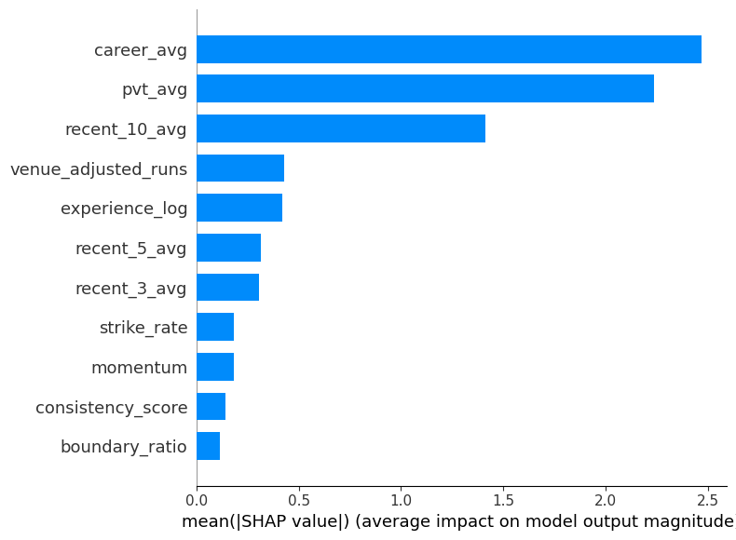

4.4 Streamlit Dashboard
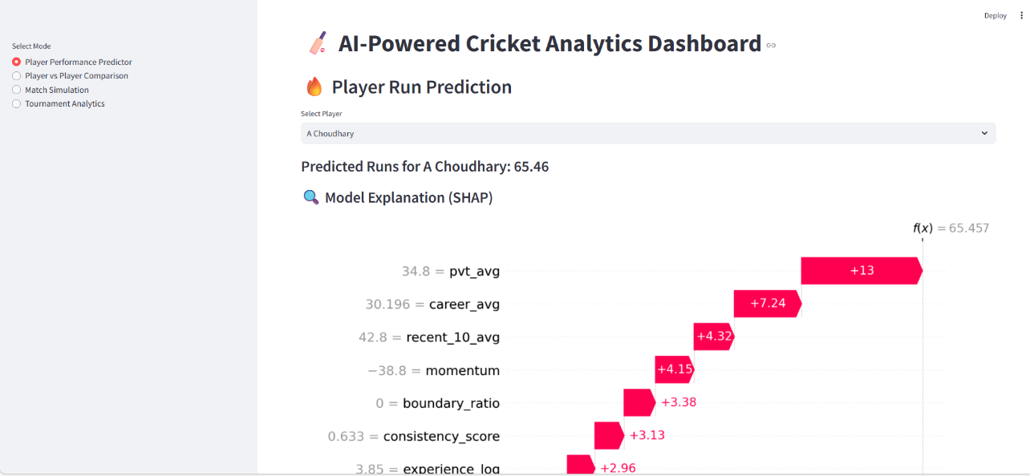

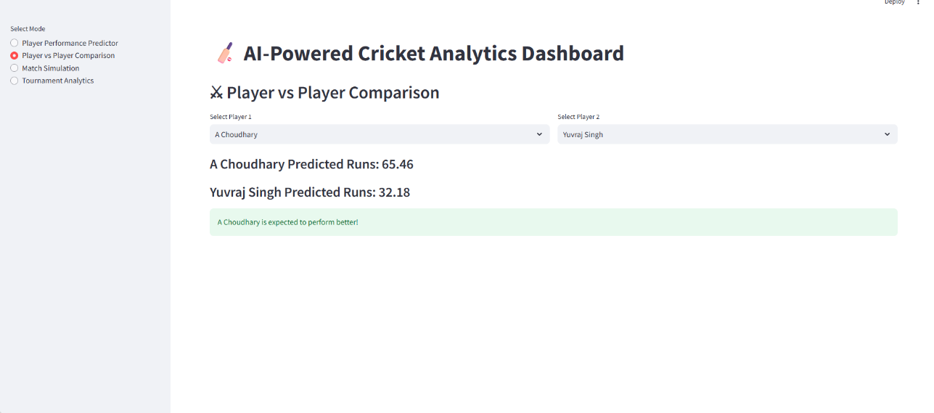

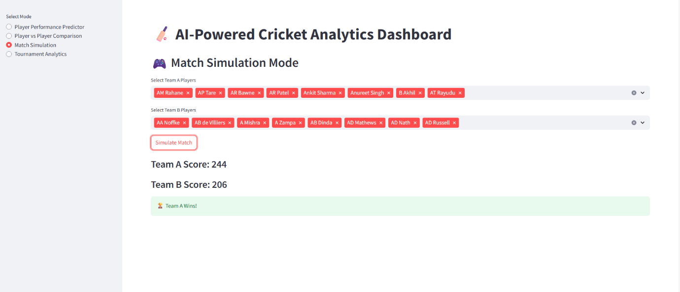
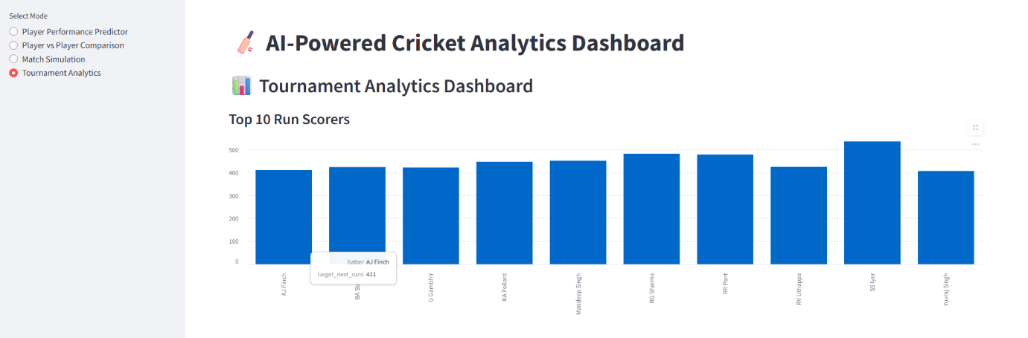
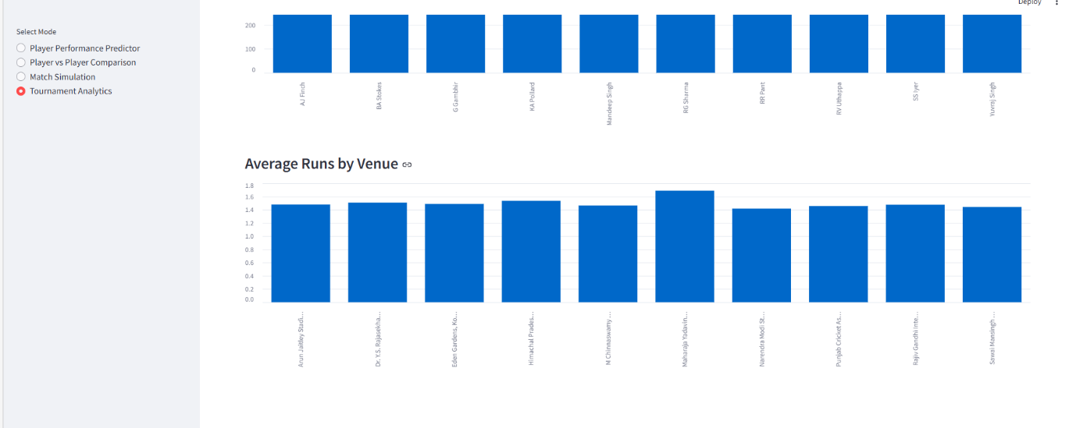

5. Conclusion.
In conclusion, I have successfully developed a complete prediction system for cricket player performance.
• Data & Features: I built a solid foundation by cleaning raw match data and organizing it into processed datasets. I engineered key features, such as player form and venue statistics, to ensure the models captured the most important factors in a match.
• Modeling: I trained advanced machine learning models that significantly outperformed simple historical averages, providing more accurate predictions for runs and wickets.
• Final Tool: I integrated these models into an interactive Streamlit dashboard, creating a practical interface where users can receive real-time performance insights.
By completing this project, I have turned complex cricket statistics into a functional tool that provides clear, data-driven predictions.

